Link
https://cmhlmc.com

Issue:
Monogram or I con is not in the center and needed to align
STEPS:
Open website

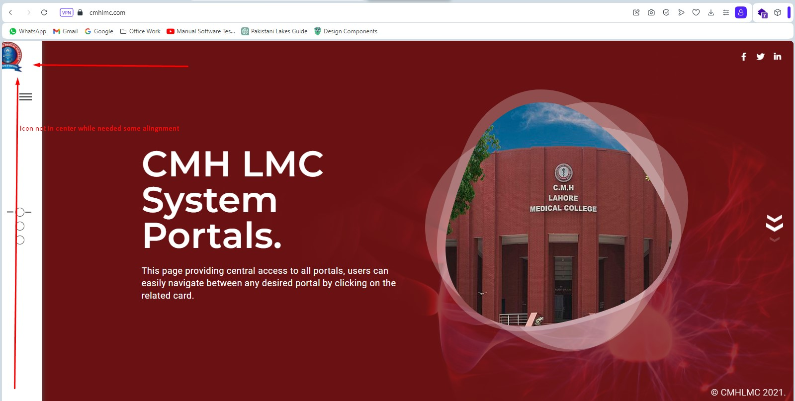

Issue:
1. Color combination needed to changes
2. The logo needs to be clear.
STEPS:
Open employee portal

